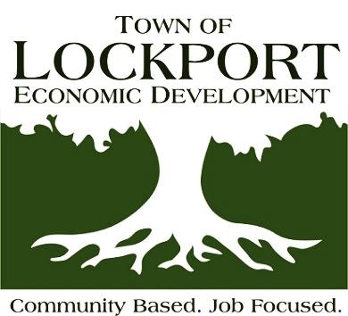
IDA / Economic Development
6560 Dysinger Road
Lockport, NY 14094-7970
(716) 478-0608
Fax (716) 439-9715

www.LockportEconomicDevelopment.com
Email: LED@Elockport.com

BOARD OF DIRECTORS MEETING

Thursday, October 14th, 2021

AGENDA

- Call to Order:

3.) General Business:
- Secretary’s Report
      - Approval of the minutes of the meeting of September 16th, 2021

- Treasurers Report
- Approval of the September 30th 2021 Financial Statements
- Approval of the invoices and bills for Thursday, October 14th, 2021
- Approval of 2022 Budget

4.) Administrative Directors Report:
a.) Monthly Report
b). Executive Director Evaluation forms
c). Project Cost Benefit Analysis software
d). Orange County IDA, Local IDA Audit Findings
e). Town Website Redesign Work – home page complete
f). Board Self Evaluation - November
g). Highlights of NYSEDC Annual Conference

5.) Attorney’s Report:
a). Yahoo Land Reconveyance
b). Bison Bag Closing

6.) Old Business:

7.) New Business:

8.) Executive Session (If requested) – Consultation with Attorney

9.) Next Meeting – Thursday, November 18th (due to Veteran ‘s Day)

Conference Room set up for social distancing and phone in line will be available upon request

