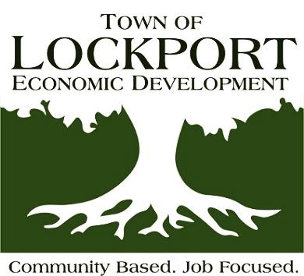
IDA / Economic Development
6560 Dysinger Road
Lockport, NY 14094-7970
(716) 478-0608
Fax (716) 439-9715

www.LockportEconomicDevelopment.com
Email: LED@Elockport.com

BOARD OF DIRECTORS MEETING

Thursday, November 18th, 2021

AGENDA

- Call to Order:

2.) General Business:
- Secretary’s Report
      - Approval of the minutes of the meeting of October 14th, 2021
      - Communication on Cambria Bear Ridge Solar and 94-C process

- Treasurers Report
- Approval of the October 31st 2021 Financial Statements
- Approval of the invoices and bills for Thursday, November 18th, 2021

3.) Administrative Directors Report:
a.) Monthly Report
b). Executive Director Evaluation Results
c). Project Cost Benefit Analysis software
d). Workplace Harassment Training Reminder
e). Open Meetings Law - packets
f). Board Self Evaluation – November
g). Town Holiday Celebration

4.) Attorney’s Report:
a). Yahoo Land Reconveyance
b). Concept Concrete Release

5.) Old Business:
a). Commerce Dr Road Extension Costs

6.) New Business:

7.) Executive Session (If requested) – Consultation with Attorney

8.) Next Meeting – Thursday, December 9th

Conference Room set up for social distancing and phone in line will be available upon request

